[UIRP 2025] Final Report

Group Information

Team |  | ICE (Ion-Cryogenic Etching)
Research Topic |  | Development of an etch simulator for optimizing etch profiles
Research Period |  | ☐ 1st Short-term Long-term ☐ 2nd Short-term
Professor |  | 김병조 Byungjo Kim |  | Affiliation | 반도체소재부품대학원
TA |  | Student No. | Name | Affiliation
 |  | 20255213 | 선우영민 Youngmin Sunwoo | 반도체소재부품대학원
Undergraduate  Members | Internship Credits | Student No. | Name | Affiliation
 | 3 | 20201330 | 홍준표  Junpyo Hong | 전기전자공학과
 | 3 | 20221287 | 이도훈  Dohun Lee | 전기전자공학과
 | 0 | 20255537 | 박현지  Hyunjee Park | 기계공학과

Abstract

Keywords | Plasma Etching, High-Aspect-Ratio (HAR), Molecular Dynamics (MD), Mixture Density Network (MDN), Monte Carlo (MC) Simulation
As the semiconductor industry advances, demands for miniaturization and integration continue to grow. This scaling trend relies on precise fabrication techniques such as plasma etching, where forming and controlling high-aspect-ratio (HAR) structures has become critical. Etch uniformity in HAR structures is affected by process temperature and ion energy and angle, significantly impacting overall process reliability.

This study proposes a predictive simulation framework that quantitatively captures ion–surface interactions under nanoscale conditions. Molecular dynamics (MD) simulations were used to obtain energy–angle distributions (EADs) from single Ar ion bombardment. These data trained a mixture density network (MDN) to construct an AI-based encoding model predictive surrogate model that predicts probability density functions (PDFs) for ion–surface reactions.

Sampled PDFs were converted into event tables and used as inputs to a Monte Carlo (MC) simulator. The direct Monte Carlo framework was designed to simulate energy accumulation on trench sidewalls within nanoscale HAR structures. Results showed that aspect ratios limit ion penetration depth, impacting process uniformity. The results of our model can be used to suggest optimal initial ion conditions for future process optimization.

By integrating atomistic MD precision with scalable MC modeling, the framework provides a practical tool for predictive simulation and process optimization in next-generation semiconductor manufacturing.

Research Contents
- Introduction
The semiconductor market, one of the most advanced industries, continues to exhibit steady growth. According to the World Semiconductor Trade Statistics (WSTS), the global semiconductor market is projected to reach USD 700.874 billion in 2025, representing an 11.2% increase from USD 630.5 billion in the previous year. The rapid proliferation of artificial intelligence (AI) has sharply increased the demand for high-bandwidth memory (HBM), while major technology companies are actively entering the AI semiconductor sector, thereby accelerating industry-wide advancement.

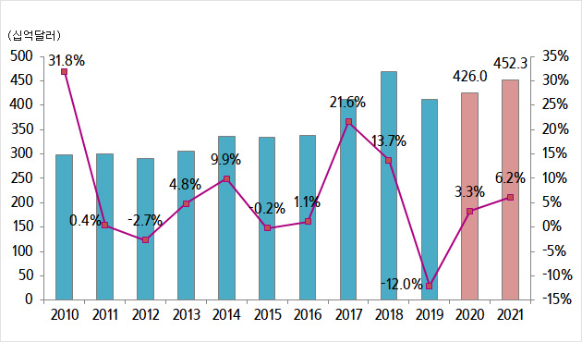
Figure 1. Semiconductor Market Growth Trends (Source: Samsung Securities)

Since the advent of Moore’s Law, the semiconductor industry has relentlessly pursued higher performance and greater integration, driving device line widths down to the nanometer scale. In this context of intense technological competition, companies are racing to develop next-generation fabrication technologies.
Achieving higher integration density requires precise control of process steps, with nanofabrication techniques such as plasma etching and deposition playing a particularly critical role. However, despite their extensive use in industry, the fundamental mechanisms underlying these processes remain insufficiently understood in many aspects.

For instance, in plasma etching, the detailed physical mechanisms by which plasma ions interact with the substrate to induce etching have not yet been fully elucidated. Direct observation of atomic-level reactions during processing, using techniques such as Transmission Electron Microscope(TEM), is severely constrained by technical and physical limitations. Moreover, experimentally probing such mechanisms through repeated process iterations is highly impractical. Consequently, simulation-based approaches that replicate realistic process conditions in a virtual environment provide a powerful means to overcome the limitations of experimental repetition, while reducing reliance on costly physical equipment and enabling deeper insight into process mechanisms.

In this study, we employ such simulation approaches to optimize the formation and control of High-Aspect-Ratio (HAR) structures, which have recently emerged as a major industrial challenge. Within HAR structures, etching uniformity deteriorates and lateral damage readily occurs due to ion transport pathways, energy dissipation, and wall interactions. By performing Molecular Dynamics (MD)-based simulations, we quantitatively analyze these phenomena and confirm their significant impact on overall process yield and reliability.

Furthermore, leveraging data obtained from MD simulations, we aim to construct a Deep Neural Network (DNN) model and integrate it with Monte Carlo (MC) methods to elucidate the complex mechanisms governing semiconductor microfabrication processes.

- Research Purpose

The primary objective of this study is to propose an approach to elucidate the mechanisms of the etching process, which remain insufficiently understood in the field of semiconductor technology, particularly in plasma etching. Through this effort, the specific research aims are as follows:

First, to understand how semiconductor etching processes are carried out through simulation and to predict the molecular behavior involved. Using Molecular Dynamics (MD), we analyze ion–surface interactions and the molecular interactions that occur during the process.

Second, to propose a method of training AI models with the results of Molecular Dynamics simulations in order to predict the Energy–Angle Distribution (EAD). This allows the modeling of process behaviors under various conditions without the need for repeated experiments.

Third, to construct a deep learning–based framework that can describe statistical behaviors and capture the probabilistic characteristics observed in real processes. This enables the development of a generalized model that goes beyond experimental and simulation results.

Fourth, to examine the potential for process optimization using a combined simulation–AI framework. This aims to establish new design guidelines that simultaneously secure energy efficiency, uniformity, and precision in semiconductor etching processes.

In addition, this research seeks to enhance our expertise in semiconductor processes while fostering the capabilities necessary to grow as professional semiconductor researchers. By applying academic knowledge to practical problem-solving throughout the project, this study plays a crucial role in laying the foundation for future development as a researcher.

- Research Methods

3.1 Molecular Dynamics
Molecular Dynamics (MD) is a numerical method for solving Newton’s equations of motion at the level of atoms or quasi-molecular models. It can also be described as the process of determining the positions of all atoms within a molecule as a function of time.

The ultimate goal of MD is to investigate the time-dependent physical properties of molecular systems through such calculations. Since MD involves numerically integrating the equations of motion, it deals with time in a discrete manner. Based on this Molecular Dynamics approach, computer simulations can be constructed, which we refer to as MD Simulation (hereafter denoted as MD).

3.1.1 MD Simulation
MD is a computational simulation method used to analyze the physical motion of atoms and molecules. Atoms and molecules are allowed to interact over a certain period of time, thereby revealing the dynamic evolution of the system. In the most common version, the trajectories of atoms and molecules are determined by numerically solving Newton’s equations of motion for a system of interacting particles.

The interparticle forces and potential energy are often calculated using atomic potentials or molecular mechanical force fields, and this method is mainly applied in chemical physics, materials chemistry, and biophysics.

Since molecular systems generally consist of an enormous number of particles, it is impossible to analytically determine the properties of such complex systems. MD addresses this issue by employing numerical methods.

However, long-term MD simulations are mathematically ill-conditioned and tend to accumulate errors in numerical integration. These errors can be minimized through the use of appropriate algorithms and parameter choices, but they cannot be completely eliminated.

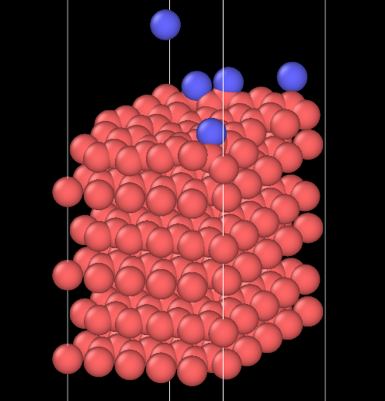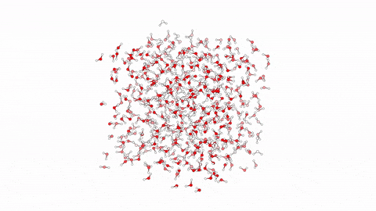
Figure 2. MD Visualization Using Ovito & MD Simulation Results (Source: Wikipedia)

3.2 LAMMPS
LAMMPS, short for Large-scale Atomic/Molecular Massively Parallel Simulator, is a classical molecular dynamics simulation code that is widely used in the field of materials science. It is primarily employed to model a variety of systems, including metals, semiconductors, biomolecules, polymers, and granular materials. Distributed under the GNU General Public License version 2 (GPLv2), LAMMPS is open source and can be freely used and extended.

The main features of LAMMPS include parallel processing and scalability, support for diverse particle types and length scales, a wide range of interatomic potentials, various ensembles and constraints, integrated algorithms and output capabilities, as well as extensibility and flexible scripting. In this study, we utilized the LAMMPS program to design and perform molecular dynamics simulations.

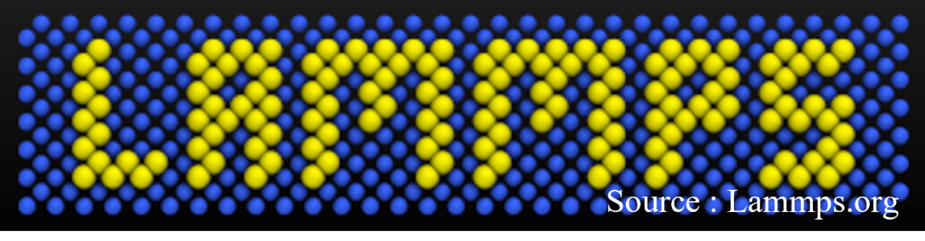
Figure 3. Lammps Logo

3.3 MD Simulation Design

3.3.1 Modeling of the Initial Structure
The simulations were performed using the open-source MD package LAMMPS, while OVITO (OVITO, Darmstadt, Germany) was employed for visualization of atomic structures. The simulation unit system was set to metal, and the atom style was defined as atom_style charge to include charges. The boundary conditions were periodic in the x and y directions and free in the z direction, thereby mimicking a semi-infinite substrate. The time step was fixed at 0.001 ps.

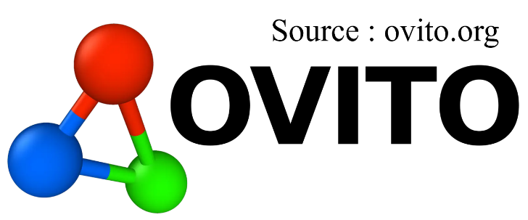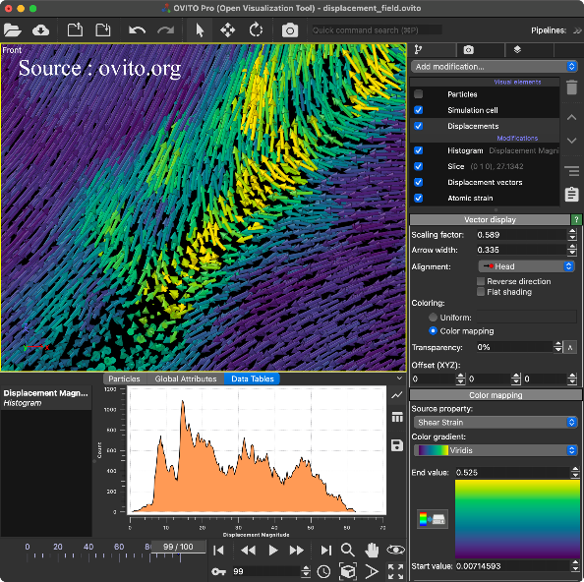
Figure 4. Ovito and its operation

The substrate was constructed using a previously reported crystalline Si file, while the incident ions were defined as Ar. The bottom region of the substrate was fixed with zero force applied to atoms to realize a mechanically constrained bottom layer. The region immediately above the bottom layer was used as a thermostat layer for dissipating energy following collisions. A hybrid potential approach was employed: the Tersoff potential was used for Si–Si interactions, while the Ziegler–Biersack–Littmark (ZBL) potential was applied to Ar–Si and Ar–Ar pairs in order to accurately reproduce short-range repulsion during ion impacts. The switching radius of the ZBL potential was set to 3.0–4.0 Å to ensure strong nuclear repulsion in the collision regime.

For monitoring the thermodynamic state of the initial structure, a temperature compute was assigned to the group consisting only of the substrate, and the substrate temperature was recorded throughout the simulation. This allowed verification that the impact energy was properly dissipated and that the generalized substrate state was adequately represented. To achieve this, the simulation applied NVE for a short period immediately after impact, followed by NVT to physically disperse the energy introduced by the collision into the interior of the substrate. The incident Ar ions were excluded from thermostats to avoid artificial interference with their dynamics.

3.3.2 Ion Impact Simulation
Ion–surface interactions were modeled by a sequential event-based injection scheme. In this study, single bombardments of Ar onto the Si substrate were repeated ten times to observe the substrate’s response. Each main loop executed ten sub-loops, resulting in a total of ten ions being sequentially injected. Randomization and random seeds were used to emulate a wide range of impact scenarios. For each bombardment, a single Ar ion was inserted into a region located 30 Å above the top of the simulation box. The initial kinetic energy was randomly assigned within the range of 0.1 eV to 100 eV to represent various conditions, while the incident polar angle was randomized between 0° and 70°, and the azimuthal angle between 0° and 360°. For each bombardment, the incident position, velocity, angle, and energy were recorded in dump files at the moment of injection, and sputtered Si atoms were collected in sputtered.dump. Post-impact configurations were also recorded for subsequent analysis.

3.3.3 Post-impact Thermal Relaxation and Optional Anneal
In this study, a short thermal relaxation stage at 300 K was included after each bombardment to implement physical heat dissipation in the substrate. Immediately after ion injection, the simulation was run under NVE to disperse the energy deposited by the collision, after which NVT was applied to the substrate region to simulate heat diffusion into the lattice. The bottom fixed layer remained constrained throughout the simulation, providing a mechanical boundary condition equivalent to the bulk, while the injected Ar ions remained under NVE conditions to prevent distortion of their behavior. The substrate-only temperature was monitored within LAMMPS to confirm that the average temperature increased cumulatively with successive impacts.

3.4 AI Predictive Model Development and Ion Trajectory Simulation
This study presents a novel methodology for analyzing ion trajectories and energy distribution within a trench by combining Monte Carlo simulation techniques with a deep learning-based predictive model. The overall research was divided into two main stages: AI Predictive Model Development and Ion Trajectory Simulation.

3.4.1 AI Predictive Model Development
To model the complex physical properties of ion-surface interactions, a machine learning-based surrogate model was developed. This model takes the energy and incident angle of an ion at the point of collision with a surface as input and predicts its reflection direction and energy loss after the collision.

3.4.1.1 Data Preprocessing
The data for model training was sourced from CSV files (mdn_input.csv, mdn_output.csv) containing the incident and reflected states of ions. Input variables were defined as the 3D velocity components (V_{X}, V_{Y}, V_{Z}) and energy (E_{in}) of the incident ion, while output variables were the 3D velocity components (V_{X}′, V_{Y}′, V_{Z}′) and energy (E_{out}) of the reflected ion. For improved neural network training efficiency, all variables underwent feature scaling using StandardScaler to achieve a mean of 0 and a standard deviation of 1.

3.4.1.2 Model Architecture
The predictive model was built on a Mixture Density Network (MDN) architecture. Unlike a conventional neural network that predicts a single value, an MDN outputs a probability distribution composed of a mixture of several Gaussian distributions, which effectively models the uncertainty inherent in ion reflection. Training incorporated an Early Stopping technique, where training was halted when the validation loss reached its minimum.

3.4.2 Ion Trajectory Simulation
To simulate the dynamic behavior of ions inside the trench, a Monte Carlo simulation was performed following these steps.

3.4.2.1 Trench Modeling
The simulation environment was implemented as a 2D trench structure defined by a set of predetermined vertices. Nodes were generated at uniform intervals along the trench contour to serve as points for accumulating ion energy.

3.4.2.2 Ion Simulation Loop
Ion Generation
Ions were randomly generated at an initial position and direction within a defined range at the top of the trench. The initial energy (E_init) was set to reflect the energy distribution of the training data.
Trajectory Tracking
The linear trajectory of each ion was tracked until it collided with a trench wall.
Collision Handling
Upon detecting a collision, the ion's incident state (incident angle, energy) was calculated. This information was then used as input for the previously developed MDN surrogate model.
Reflection Prediction
The MDN model's output determined the reflection direction and energy after the collision. The possibility of the ion being absorbed into the wall, known as implantation, was also considered during this process.
Energy Recording
The energy transferred by the ion was accumulated at the trench nodes surrounding the point of collision or implantation. The energy was distributed with a weight based on the distance from the collision point.

- Research Schedule

Month | Major Activities
March | - Comprehensive literature review on semiconductor processes and understanding of etching processes  - Understanding of AI and machine learning concepts and related knowledge study
April | - Design methodology of MD simulation using LAMMPS and a tutorial process through simple simulation execution  - Development of a Python-based data processing model for preprocessing MD simulation data
May | - Design of MD simulation for single bombardment on a Si substrate using LAMMPS  - Design of an MDN model utilizing MD simulation results with PyTorch
June | - Execution of one million simulations based on CPU for the designed simulation and development of the AI model  - Construction of a Monte Carlo framework capable of ion generation, trajectory tracking, and collision detection
July | - Analysis and development to ensure that MD simulation results are effectively learned by the AI model  - Analysis and visualization of ion trajectories, collision points, and energy heatmaps from the Monte Carlo system
August | - Integration and development of a DNN model developed using MD simulation with Monte Carlo simulation  - Report writing and poster preparation

- Research Results

5.1 Analysis of Ion Collision and Collision Cascades
In this study, molecular dynamics (MD) simulations were employed to investigate the phenomena that occur during the collision of an ion with a substrate. The events arising from the bombardment of a silicon (Si) substrate with argon (Ar) ions were simulated using the LAMMPS (Large-scale Atomic/Molecular Massively Parallel Simulator) package. The results from these simulations are presented as follows.

5.1.1 Temporal Visualization of the Interaction

5.1.1.1 Prior to Impact
At the commencement of the simulation, an Ar ion is generated with a prescribed kinetic energy and incident angle and proceeds to approach the substrate. The accompanying figure provides a schematic representation of the initial state of the simulation system.

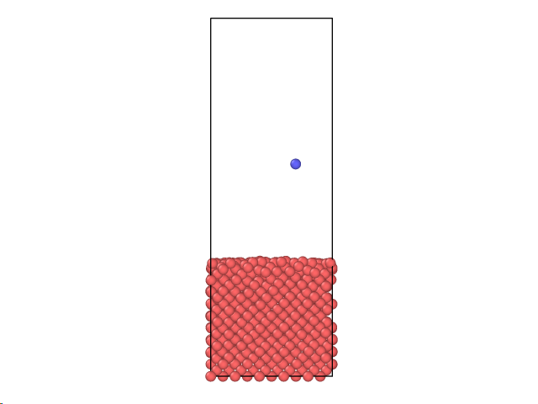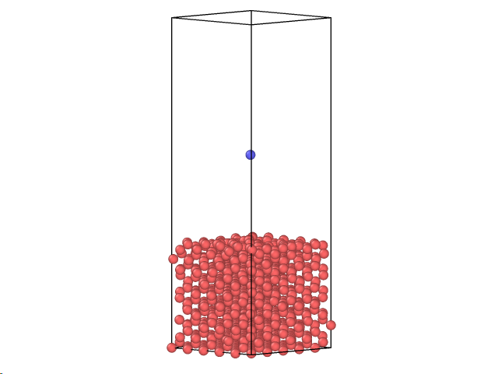
Figure 5. Initial position of the incident ion

5.1.1.2 Initial Collision and Ion Energy Transfer
The initial angle and energy of the incoming Argon (Ar) ion determine the specific point of collision with a surface Silicon (Si) atom. Upon this collision, the Ar ion transfers most of its kinetic energy. Consequently, the energized Si atoms subsequently transfer this energy, causing the structure to change. In particular, a strong collision can result in the ejection of a Si atom, a process known as sputtering. It was observed that for Ar ions with energies of 40 eV or more, sputtering of the Si atom can occur upon direct collision, though this is dependent on the angle of incidence.

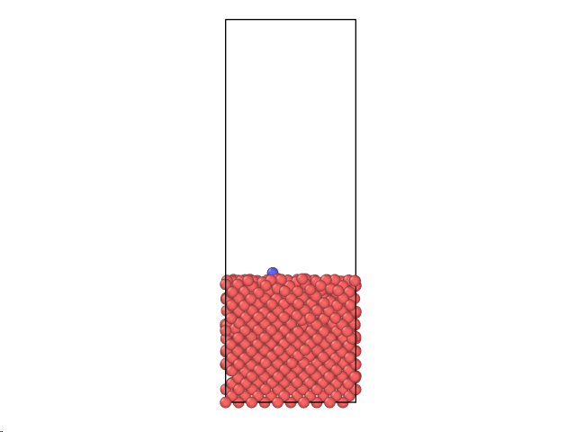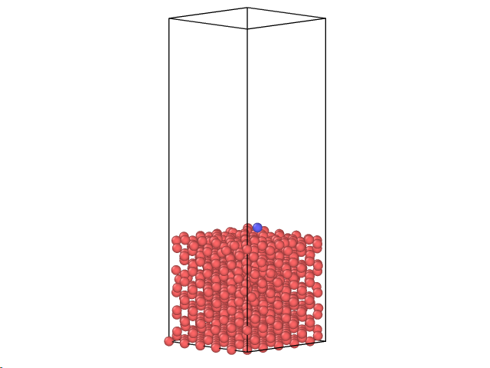
Figure 6. Ion collision

5.1.1.3 Sputtering and Scattering
Depending on the angle and energy of the incoming Ar ions, they either scatter or collide forcefully with the substrate, leading to the sputtering of Si atoms. When the ions were bombarded with energies ranging from 0 eV to 100 eV, the total number of sputtered Si atoms was 58,319, which was not a particularly high yield. The energy distribution of the sputtered Si atoms is presented below. It was observed that sputtered atoms with kinetic energies below 0.2 eV accounted for 41% of the total, indicating that a majority of the sputtered atoms possess very low energy.

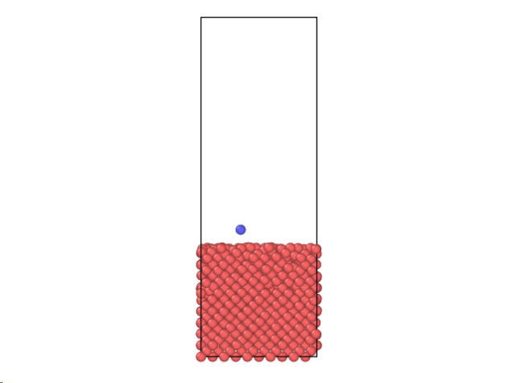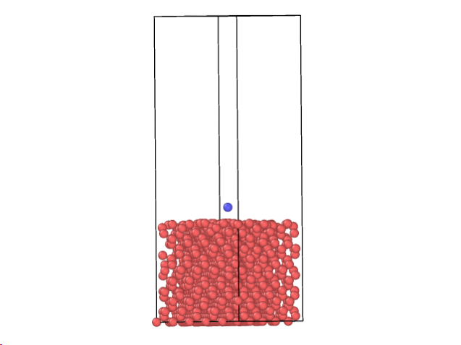
Figure 7. Reflecting Ion Simulation

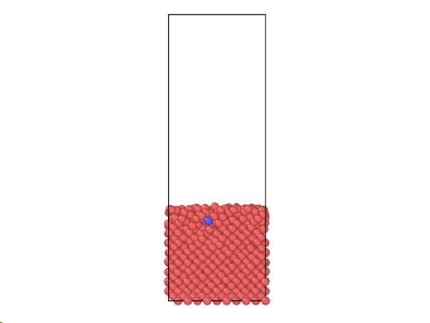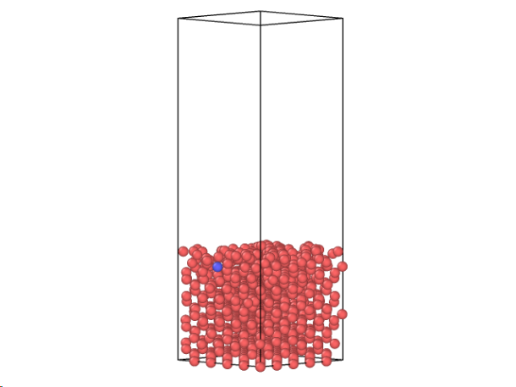
Figure 8. Injected ion simulation

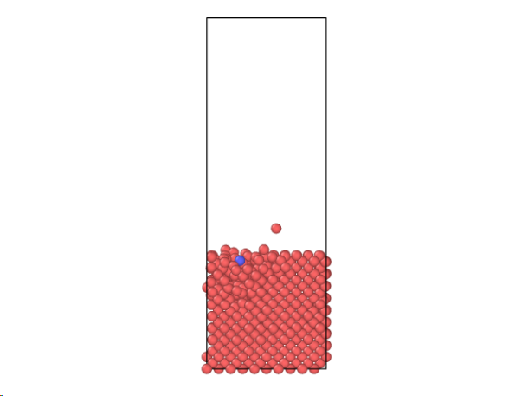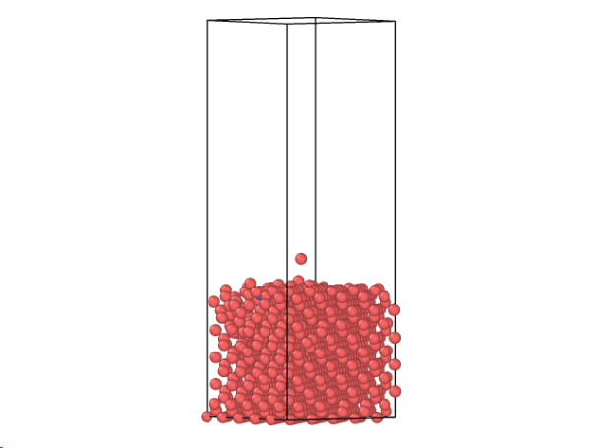
Figure 9. Sputtering ion simulation

5.1.1.4 Substrate Stabilization
Following the sputtering process, the substrate was observed to regain a stable structure after the departure of the ions. After this stabilization and subsequent ion rearrangement, new Argon (Ar) ions were introduced, ultimately defining the final morphology of the substrate.

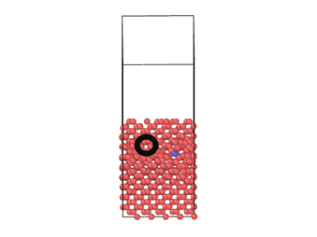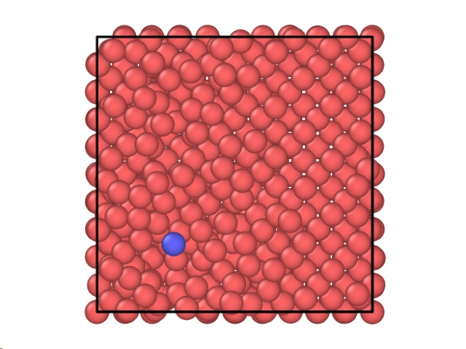
Figure 10. Sputtered ions and the stabilization process
5.1.2 Quantitative Analysis of Each Simulation
We conducted a total of 1,000,000 Ar bombardment simulations by repeating a simulation of 10 Ar ions being bombarded 100,000 times. We need to verify and validate whether this simulation can accurately represent a typical etch situation.

To validate this data, we performed post-processing on the primary input data files: incident.dump(initial input), reflected.dump(information on reflected Ar), and sputtered.dump(information on sputtered Si). For data processing, we primarily used Python to write a script capable of handling large volumes of data at once.

The analysis focused on the number and ratio of injected Ar to reflected Ar, and the energy and angle distributions (EADs) of the reflected Ar ions.

5.1.2.1 Initial Ion State Analysis
Before analyzing the results, it is essential to verify whether the initial incident Ar ions were executed according to the set conditions within the simulation. We used the data from incident.dump to check this information. The graph below shows the energy distribution of the incident ions. The graph confirms that energy was consistently injected across most energy ranges. Additionally, an analysis of the number of incident ions per 10 eV interval showed that the smallest distribution was in the 0 eV to 10 eV range, with a total of 99,111 ions. The largest distribution was in the 50 eV to 60 eV range, with a total of 100,410 ions, a number well within the margin of error of the smallest range. Therefore, we can conclude that the initial ion energy data is reliable.

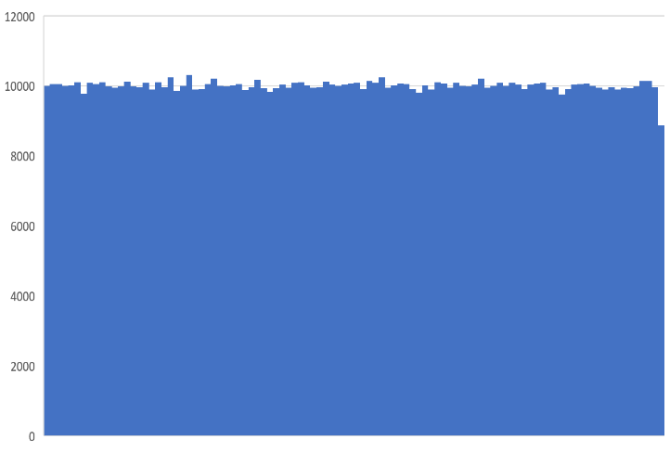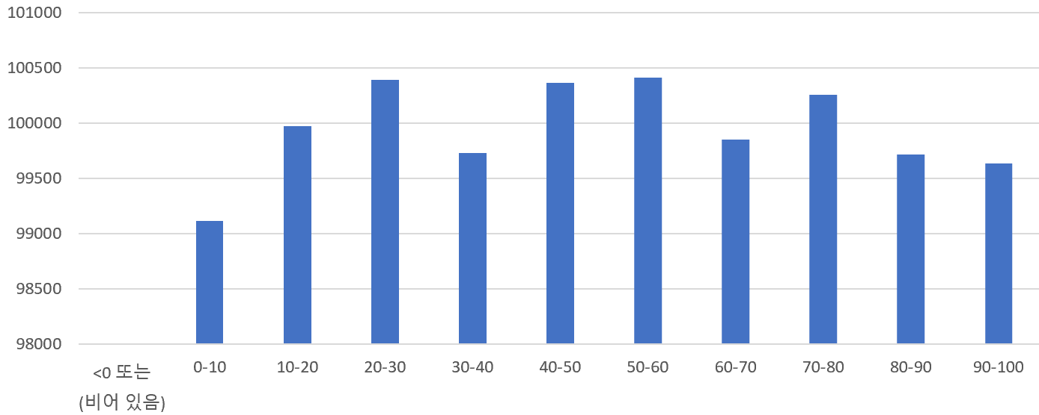
Figure 11. Histogram of initial ion energy distribution

5.1.2.2 Reflected and Injected Ar

The Molecular Dynamics Simulation data obtained in this study will be utilized to construct trenches and identify the optimal ions. This is a crucial step as it verifies how etching occurs as ions are reflected from and injected into the trench walls.

The distinction between injected and reflected ions can be determined by their final z-axis position. In our simulation, the substrate was configured to be located at 28 Angstroms from the bottom. If a final Ar ion is positioned below 28 Angstroms, it is classified as an injected ion. Conversely, if it is above 28 Angstroms, it is considered a reflected ion. We wrote a Python script to process the output data and perform this classification.

The image below shows the results from executing the Python script via Windows PowerShell. The analysis revealed 610,875 reflected atoms and 388,554 injected atoms. This corresponds to 61.1% of the ions being reflected and 39.9% being injected. Additionally, through data analysis, we confirmed that the incident angles of the Ar ions were randomly distributed between 0∘ and 70∘, with a consistent number of ions at each angle.

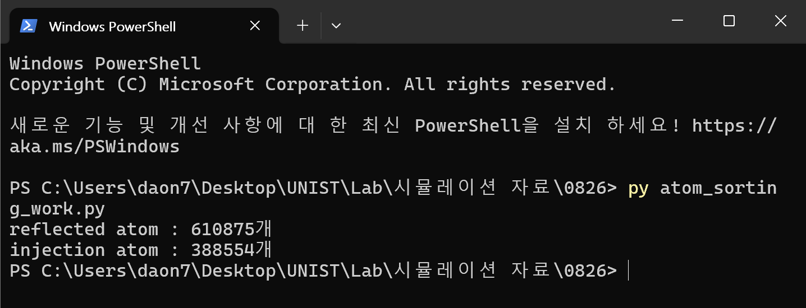
Figure 12. Injected and reflected ions analyzed with Python

5.1.2.3 Reflected Ion Energy Distribution
One of the crucial aspects of this study is understanding the energy and angle distributions of the reflected Ar ions. While this information is processed directly by the AI model, it is also necessary to analyze the data manually to understand the distribution patterns. The reflected Ar ions showed their highest concentration in the 0.07 eV to 0.08 eV range, and the distribution gradually decreased as energy increased, resembling a normal distribution.

The angle distribution graph is also shown below. An angle of 180∘ corresponds to diffuse reflection, where the ion is scattered in a direction opposite to its incidence. Conversely, an angle close to 0∘ represents specular reflection, where the ion maintains its initial direction of travel. In a broader sense, we observed that Ar ions were frequently reflected at angles between 20∘ and 30∘ after their initial collision with the Si substrate. A more detailed analysis revealed that the most frequent reflection angle was between 28∘ and 29∘. The subsequent decline in distribution after 28∘ was interrupted by a local maximum at 108∘, which we attribute to the interaction of a small number of ions or a simulation error.

The process of determining the precise distributions or normal distribution functions for this data was conducted during the pre-processing stage before inputting the data into the AI model. Based on this brief data analysis, we concluded that the simulation accurately represents the single bombardment of Ar on a Si substrate, and we proceeded with the subsequent AI training.

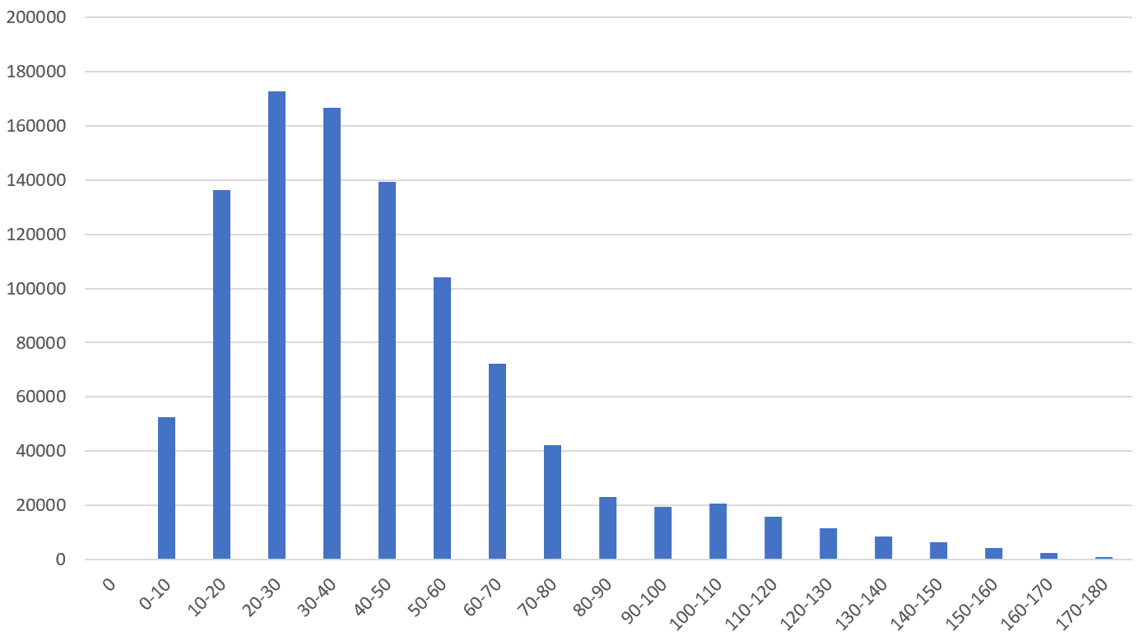
Figure 13. Data on angles

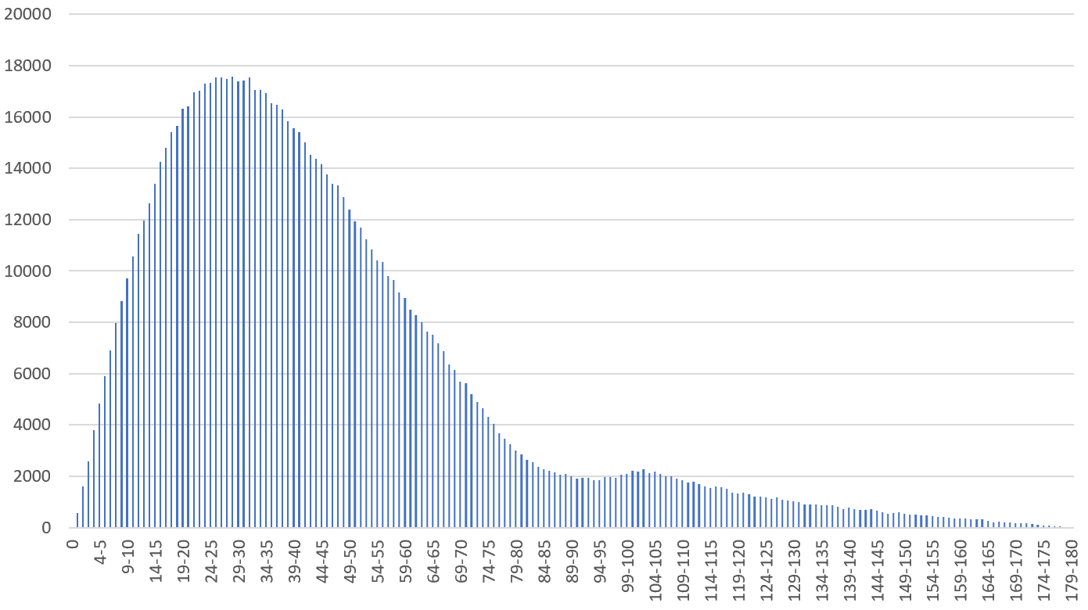
Figure 14. Detailed data on angles

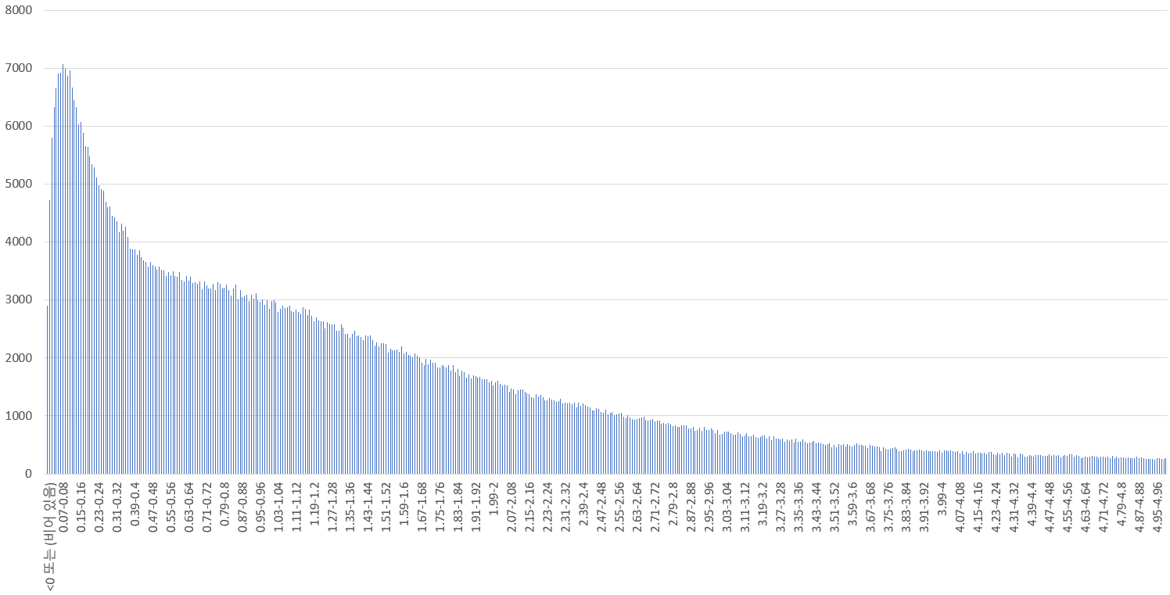
Figure 15. Data on the reflected ions

5.2 Sputtering Yield and Etch Rate
Sputtering yield, etch rate, and selectivity are commonly used metrics in the analysis of etching processes. However, using these metrics in this study is not appropriate.

To minimize computational cost, the simulation code was designed to bombard and stabilize ions at a much faster rate than what occurs in an actual etch process. Simulating the process at a realistic time scale would require an astronomical amount of time. Due to these time and computational cost constraints, the sputtering yield and etch rate values would be unrealistically high. Therefore, we did not perform an analysis on these specific metrics in this study.
Based on the developed AI-driven simulation methodology, this study analyzed how ions behave and transfer energy within a trench. The key findings are as follows.

5.3 Performance and Predictive Capabilities of the MDN Model
5.3.1 Model Training and Convergence
For the analysis, a Mixture Density Network (MDN) was adopted in place of a conventional Deep Neural Network (DNN). The model training results indicated a stable decrease and convergence of both the training and validation losses as the epochs progressed. This suggests that the model successfully learned the underlying patterns within the training data. Notably, an early stopping algorithm was implemented to halt the training when the validation loss stabilized, thereby securing an optimal model prior to the onset of overfitting.

5.3.2 Probabilistic Prediction and Output Distribution Analysis
The script designed in this study demonstrates an end-to-end pipeline for applying the trained MDN model to practical problem-solving. The data processing workflow was structured systematically, internally managing a sequential process that includes input transformation, data normalization, model inference, and inverse normalization. The AI model was configured to process and transform the three-dimensional data from the simulations into a two-dimensional format for analysis. Through this pipeline, the physical validity of the model was verified, confirming that the prediction results were well-represented.

5.4 Ion Trajectory and Interaction Analysis
A simulation of 100 ions showed that most ions created complex trajectories by colliding with the trench walls multiple times. The simulation results indicate that even a small difference in initial incidence angle can significantly alter an ion's trajectory, which reflects the probabilistic nature of reflection as predicted by the MDN model. Some ions reached deep inside the trench and impacted the bottom wall, while others were observed to be absorbed and implanted into the walls.

A focused analysis on Node 123 clearly traced the trajectory of an ion, such as Ion 46, which transferred energy to this specific node with a single collision. This result demonstrates that the simulation can precisely identify which ion paths affect a particular location.

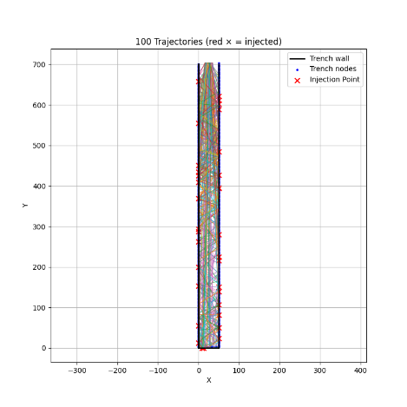
Figure 16. Visualization of 100 ion trajectories and their interactions

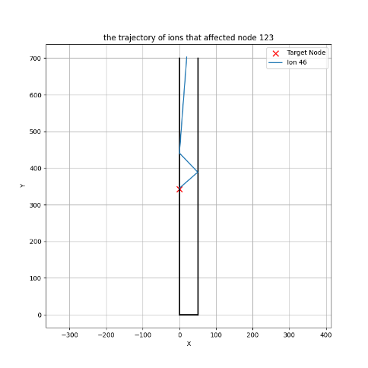
Figure 17. Trajectory of Ion 46 affecting Node 123.and their interactions

5.5 Cumulative Energy Distribution
Visualizing the cumulative energy on the trench nodes revealed that energy was not distributed uniformly across the walls but was instead concentrated in specific areas. The simulation results showed that nodes near the trench entrance and the bottom recorded relatively high cumulative energy, suggesting that collisions occurred most frequently as ions entered the trench or reached its base.

An analysis of the terminal output data confirmed that the cumulative energy for each node was recorded in detail. For example, Node 28 recorded a high cumulative energy of 134.39, which can be interpreted as the result of concentrated ion impacts. This data can be used to quantitatively evaluate the energy transfer efficiency of the ion beam in a trench process and to predict potential issues like surface damage.

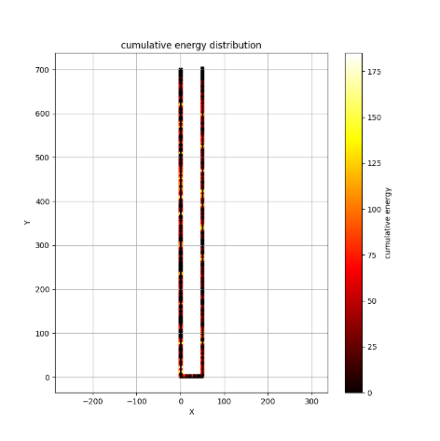
Figure 18. Cumulative Energy Distribution

5.6 Ion State Change and Trajectory Characteristics
By tracking the ion's 3D vector and energy changes throughout the simulation, we confirmed that both direction and energy changed with each collision. The initial energy (E_init) progressively decreased, accurately reflecting the energy loss upon each wall impact. As seen in the terminal output, each ion experienced multiple "bounces" as it continued its trajectory. Some ions lost nearly all their energy after a few collisions and became implanted, demonstrating that the MDN model can successfully predict ion absorption.

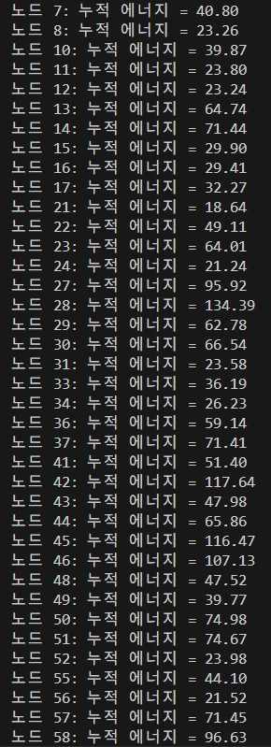
Figure 19. Cumulative energy values for each trench node

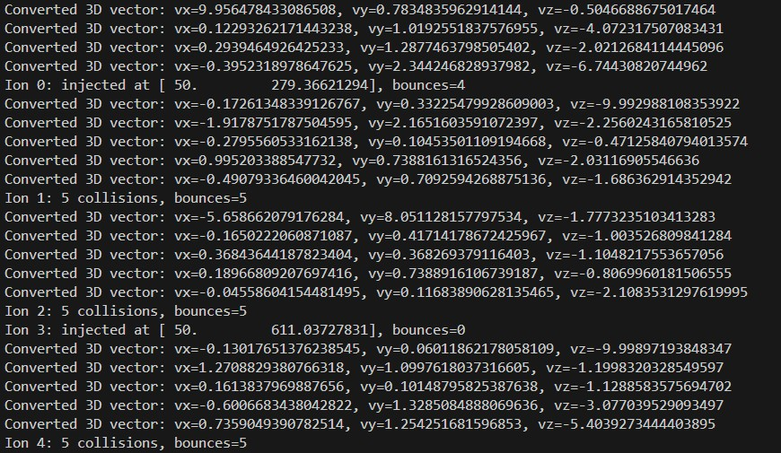
Figure 20. Ion state changes and final outcome
The output, as shown above, clearly illustrates the changes in ion state, proving that the number of bounces, final position, and post-collision 3D vector predictions were accurately recorded.

- Research Achievements

Participation in academic societies
“Poster Presentation at the 78th Gaseous Electronics Conference”

Our research has been accepted for a poster presentation at the 78th Gaseous Electronics Conference, which will take place at COEX in Seoul on October 14, 2025.

The poster presentation, titled "A physics-based simulation framework for ion transport and surface interaction analysis in high-aspect ratio etching," will be presented on October 14 under the sub-field Modeling and simulation: computational methods within the Plasma Science category.

- Expected Contribution / Future Plans
7.1 Expected Contributions
This study integrates a deep learning-based Mixture Density Network (MDN) with a traditional Monte Carlo simulation, and we anticipate the following key contributions to the field of ion-surface interaction modeling.

7.1.1 Methodological Innovation
Conventional ion simulations often rely on simple empirical models (e.g., specular or cosine reflection), which fail to capture the full complexity of real-world phenomena. This research presents a new hybrid simulation methodology that utilizes an MDN surrogate model to probabilistically predict ion-surface interactions, thereby more accurately mimicking complex, nonlinear physical events. This represents a significant contribution by elevating the physical accuracy of the simulation.

    - Enhanced Computational Efficiency
The MDN surrogate model replaces computationally expensive, physics-based simulations with a neural network that is incredibly fast to run. Once trained, the MDN model provides near-real-time prediction capabilities, making this approach particularly valuable for large-scale studies that require simulating hundreds of thousands of ions.

    - Scalability and Flexibility
The developed model is not limited to a specific material or ion type. By simply retraining the model with new experimental or physical simulation data, the simulation environment can be flexibly adapted to a wide range of conditions. This provides a robust foundation for various industrial applications.

7.2 Future Plans
To overcome the current limitations and broaden the accuracy and applicability of the simulation, we have established the following future research plans.

7.2.1 Expansion to 3D Simulation
We plan to expand the current 2D simulation into a full 3D environment that accurately reflects real trench structures. This will involve developing 3D trench models and creating 3D trajectory tracking and collision detection algorithms. By fully incorporating the three-dimensional nature of ion-surface interactions, we can maximize the realism of the simulation results.

    - Integration of Surface Evolution Models
While the current simulation only records energy deposition, actual processes involve simultaneous surface erosion and deposition due to ion bombardment. In the future, we will integrate surface evolution models to predict how the trench geometry changes over time, adding a dynamic layer to the simulation capabilities.

    - Model Improvement and Optimization
We plan to build a larger and more diverse training dataset to further enhance the predictive accuracy of the MDN model. Concurrently, we will optimize the simulation code itself, incorporating parallel computing with GPU acceleration to handle larger-scale simulations more efficiently.

    - Integration of KMC Methodology
To maximize the computational efficiency of the simulation, we plan to incorporate a Kinetic Monte Carlo (KMC) methodology. The current trajectory-tracking method is computationally expensive during the ion's free flight phase. By integrating KMC, we can probabilistically predict the time and type of the next collision event and advance the simulation, thereby significantly enhancing the efficiency of ion simulations, particularly in rarefied environments. The developed MDN model will serve as a key component within the KMC framework by providing the event probabilities for whether an ion will reflect or implant.

- Member’s Role
 | Name | Role | Details
1 | Jun Pyo Hong | Team leader | Building Monte Carlo models and developing based on AI data and MC data
2 | Do Hun Lee | Team Member | Design and analysis of molecular dynamics simulations and AI model development based on MD data
3 | Hyun Jee Park | Team Member | Conducted a literature survey

- References
[1] Kim, B., Kim, M., Yoo, S., & Nam, S. K. (2022). Atomistic insights on hydrogen plasma treatment for stabilizing High-k/Si interface. Applied Surface Science, 593, 153297.
[2] Kim, B., Bae, J., Jeong, H., Hahn, S. H., Yoo, S., & Nam, S. K. (2023). Deep neural network-based reduced-order modeling of ion–surface interactions combined with molecular dynamics simulation. Journal of Physics D: Applied Physics, 56(38), 384005.
[3] Hong, C., Oh, S., An, H., Kim, P. H., Kim, Y., Ko, J. H., ... & Han, S. (2024). Atomistic simulation of HF etching process of amorphous Si3N4 using machine learning potential. ACS Applied Materials & Interfaces, 16(36), 48457-48469.
[4] Tinacba, E. J. C., Isobe, M., Karahashi, K., & Hamaguchi, S. (2019). Molecular dynamics simulation of Si and SiO2 reactive ion etching by fluorine-rich ion species. Surface and Coatings Technology, 380, 125032.
[5] Hyun, S. M., & Lee, C. W. (2009). TSV core technology for 3D IC packages. Journal of the Korean Welding and Joining Society, 27(3).
[6] Shin, D. S., Seo, J., Lee, J. H., & Kim, K. H. (2009). A TSV drilling process using laser. Journal of the Korean Society for Precision Engineering, 26(12), 41-46.
[7] Shin, D. S., Seo, J., & Kim, J. O. (2010). A study on the characteristics of TSV drilling according to the process parameters of a picosecond laser. Journal of the Korean Laser Processing Society, 13(4), 7-13.
[8] Brault, P., Thomann, A.-L., & Cavarroc, M. (2023). Theory and molecular simulations of plasma sputtering, transport and deposition processes. The European Physical Journal D, 77(1), 19.
[9] Hu, Z., Li, J., Chen, R., Shang, D., Wei, Y., Wang, Z., Li, L., Filipovic, L., & Chen, R. (2024). A two-step dry etching model for non-uniform etching profile in gate-all-around field-effect transistor manufacturing. Small, 20(51), 2405574.
[10] Zhai, Y., Ge, R., Hu, Z., Li, J., Shao, H., Cheng, J., Filipovic, L., & Chen, R. (2025). Modeling the charging effect of the hardmask and silicon substrate during plasma etching in advanced nodes. Journal of Applied Physics, 137(6), 063302.

- Participants’ Comments
(Professor) The UIRP was a very important opportunity for students to experience a real research environment and cultivate their academic interests. I hope that these types of programs will continue to be active in the future
(TA) I was impressed by the undergraduate students' proactive approach to their research. Their efforts to solve difficult problems without giving up were remarkable
(Undergraduate members)
- (Jun Pyo Hong) This program has given me a lot of insight into semiconductor etching processes.
- (Do Hun Lee) I was able to gain a lot of understanding of semiconductor processes by virtually simulating a process I've always been interested in and gaining experience with MD simulations. In addition, I was able to improve my ability to analyze various information through AI and coding thanks to the UIRP.
- (Hyun Jee Park) It was a great opportunity to learn about semiconductor processes.

We hereby submit the final report for the UIRP in 2025 as stated above.

Date: | 09 / 10 / 2025
Professor: | 김병조 |   (Signature)
Student leader: | 홍준표 |   (Signature)

